EL227

Digital Logic & Design LAB

SEMESTER PROJECT

BSCS Spring 2020

By:

Aamna Kamran 19I-0454

Section B

**Introduction**

I have made a ***Digital Clock*** which makes use of basic gates along with the 2 ICs: D flip flops and 555 Timer. This digital clock shows the time in seconds, minutes and hours (top, middle, bottom respectively). This clock can begin from 00:00:00 or it can be set to begin from the time of the user’s choice.

**Components Used**

* **555 Timer:**

The 555 Timer is used to generate a constant clock pulse for the seconds to change which then goes through the circuit to eventually help in the working of the digital.

* **7 Segment Common Cathode:**

The 7 Seg Com Cathode is connected to the self-made circuit of BCD to 7 Segment Converter. It is used to display the seconds, minutes and hours of the digital clock.

* **D flip flop (74HC74):**

The D flip flops are used to make the 4-bit asynchronous counter.

* **Resistors and a Capacitor**

The resistors are used to create a voltage difference. The greater the voltage difference the higher the frequency of the clock pulse.

The purpose of the capacitor is to level out any fluctuations in the supply voltage that might affect the operation of the timer.

* **Multiple input AND, OR, NAND, NOR and NOT gates**
* **LED-RED:**

The LED is used to check if the 555 Timer Circuit is working or not – generating an alternating output which is basically a clock pulse imitation.

**Design: How everything works?**

I started off by first making a circuit for the 555 Timer IC in a way that it would provide a varying output that would serve as the *clock pulse* input for my Binary Coded Decimal to 7 Segment Display converter circuit.

|  |  |  |  |
| --- | --- | --- | --- |
| **S** | **R** | **Q(n)** | **Q(n+1)** |
| 0 | 0 | 0/1 | 0/1 |
| 0 | 1 | 0/1 | 0 |
| 1 | 0 | 0/1 | 1 |
| 1 | 1 | 0/1 | X |

If the voltage at the ***Threshold*** pin is **less than 2/3 of the vcc** then the **output** at the Comparator will be **0**, if it is greater than 2/3 of the vcc then the output at the Comparator will be 1.

If the voltage at the ***Trigger***pin is **less than 1/3 of the vcc** then the **output** at the Comparator will be **1**, otherwise it will be 0.

The output from both the *Comparators* will go into the SR flip flop which will produce an output for the 555 Timer IC according to this chart shown on the right.

The output from the Threshold Comparator will go into the SR flip flop as R, whereas the output from the Trigger Comparator will go as S.

**The following is my working for the BCD to 7 Segment Converter:**

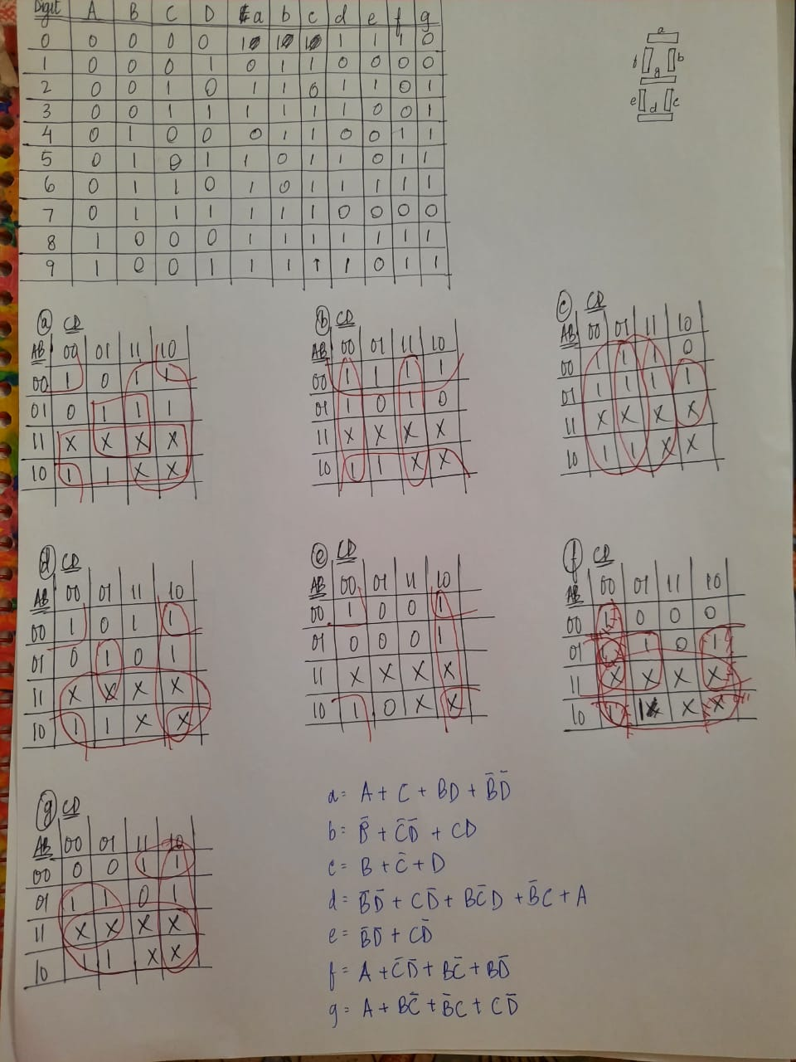

|  |  |  |  |
| --- | --- | --- | --- |
| **clk** | **D** | **Q** | **Q’** |
| 0 | 0 | Q | Q’ |
| 0 | 1 | Q | Q’ |
| 1 | 0 | 0 | 1 |
| 1 | 1 | 1 | 0 |

Then I made a 4-bit asynchronous counter using 4 D flip flops.

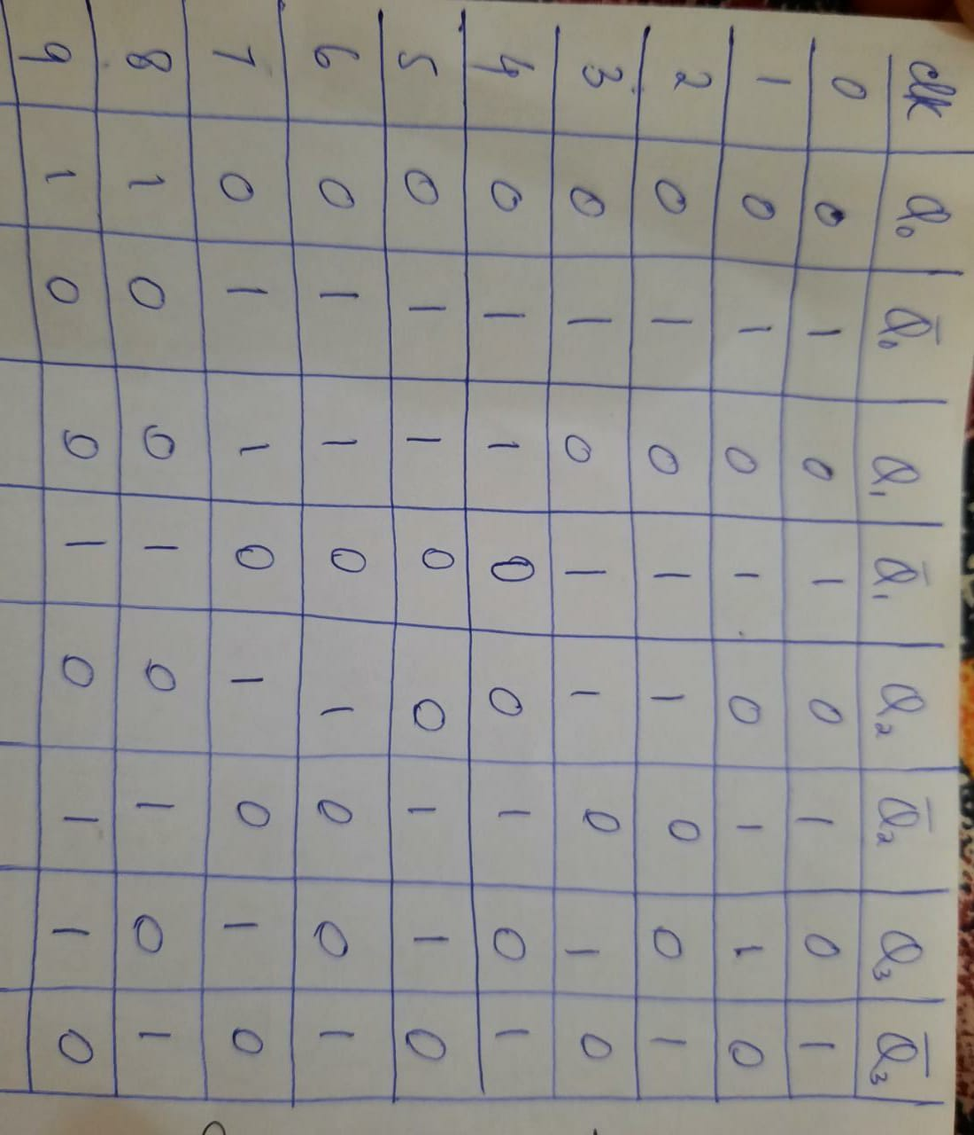

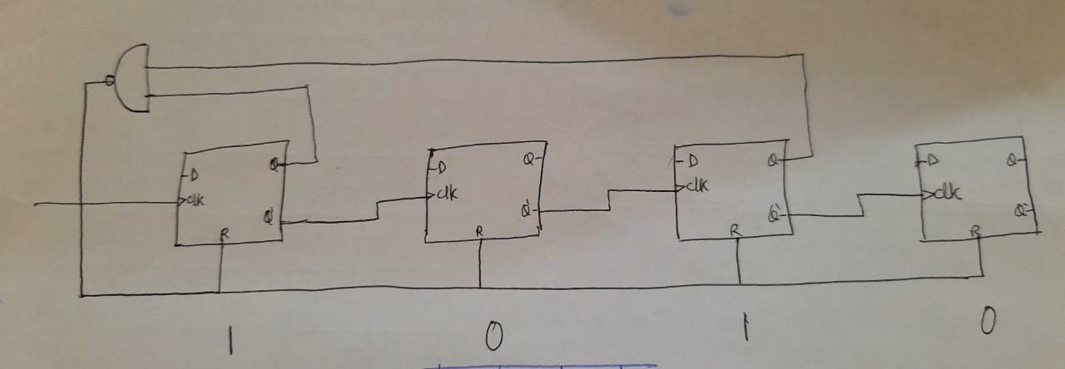

On the top are the seconds, then the minutes and on the bottom are the hours.

When the right digit of the seconds reaches 9, the NAND gate will get an input of 1 1 from the first Q and fourth Q (left to right) D flip flops respectively. This will produce an output of 0 and thus reset all the flip flops which will begin recounting from 0.

As soon as the right digit of the seconds restarts from 0 the left 4-bit asynchronous counter set up is given a clock pulse input of 1. Every time a clock pulse is given, the number displayed on the 7-segment display increase by 1 until it reaches 5. When the left digit of the seconds reaches 5, the inputs that go into the NAND gate are: 1 1 1 from the first Q’, second Q and third Q’ of the D flip flops (left to right) respectively. This will produce an output of 0 which will reset the left digit back to 0 and the seconds will begin counting from 0 again.

When the left digit is reset to 0 it gives a clock pulse to the minutes and then the minutes begin counting increasing by one each time the seconds reset after 59 seconds pass.

The same mechanism is in place for the hours to work. When the left digit of the minutes is 5 and the right digit is 9 the minutes reset and the hours increase by 1.

Another condition that I have applied is that the whole circuit will reset after 23:59:59.